Town & Country Pool & Rec Center
Pool Board Meeting
Sunday, January 12th 2025 12:30 p.m.
MINUTES
- Call to Order
A regular meeting of the Town & Country Pool Board, was held in person on Sunday, January 12th. The President, Jessica Bowen and the Chairman, Simon Bowen, were present. The President presided. A quorum being present, the meeting was called to order at 12:30 p.m.

- Attendance
Member Present: Simon Bowen, Jessica Bowen, Bill Kennard, Cynthia Kennard, John Huster, Ciji Wright, Lora Kates, Michelle Lawrence, Joy Conklin
Members Absent: Angi Davis
- Opening
  - Welcoming remarks (Jessica Bowen)

- Chairman’s Report – Simon Bowen
  - Swim Events – Asked Swim Team Leadership to ensure Pool Board is aware of events so that we do not add chemicals to the pool preventing swim team members from swimming.

- President’s Report – Jessica Bowen
  - Swim Team Representative Joy Conklin
    - All members agreed to vote Joy in as the 2025 Swim Team Rep

- Membership Report – (no updates)
  - Research being completed for 2025 Membership Rates

- Grounds Report – Bill Kennard (no updates)

- Treasure’s Report – John Huster (please review attached financial report)
  - 2025 Budget Worksheet in place; Added line item for employee appreciation.
  - W2’s for lifeguards and attendants made available on Gusto on 1/22
  - CPO Discussion – John will run numbers and Board will vote on next steps in February Meeting.
  - All membership officers will need to submit budgets for 2025.
  - Board will work to receive updated quotes for pool replaster project
  - Swim Coaches W2’s – last season coaches will be paid as contract employees and new swim team leadership will work to provide 1099s for coaches moving forward.
    - Funds were not put aside to pay swim team payroll taxes
    - All agreed the coaches should have W2s. John will assist swim team leadership with creating W2s for all the coaches. Will need each individual’s gross pay. The pool will cover the taxes.
    - Swim Team Leadership has plan in place to ensure this doesn’t occur moving forward.

- Social Report – Lora Kates (see attached)
  - Suggestion was made to not have food trucks every week in the 2025 season. Only for opening weekend.
  - Plan to post swim team and social calendars when pool membership is posted.
  - Lora will assist Jess with the pool website.

- Secretary’s Report – Ciji Wright (no updates)

- Swim Team Coordinator Report – Joy Conklin

  - Swim Team Leadership will share all dates of all swim events. All dates will be provided to the Pool board by February 1. Website will be updated.
  - Swim Team needs an announcer during meets.
  - Swim Team Guidelines for upcoming season and communication with members.
    - Will be specific about pool use for only members or those who are on the swim team for liability reasons.
    - Suggestion for swim team members to sign off on rules and include them in the registration form.
    - Swim Team Leadership agreed to keep communication open to keep things running smoothly.
    - Will work on plan for letting non-members in at the gate for practice.
  - Concessions – Swim Team will take care of their own concessions in the 2025 season.
  - Payroll – Staff should be paid bi-weekly
    - Pay period May – July

- Adjournment at 2:00 p.m.
Submitted by Ciji Wright Town & Country Pool & Rec Center | Date: January 28, 2025
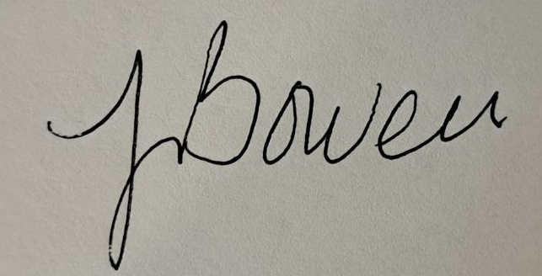
____________________________________
Jessica Bowen, President, Town & Country Pool & Rec Center
Pool Board Approval Date: January 28, 2025

